**Work 10 Blog**

In this week, I worked with the implementation of registration part of users with the health authorities and conversion of their UUIDs to a barcode using ZXING library for secure authentification of genuine users.

**Commits- 1)** <https://github.cs.adelaide.edu.au/2020-Mobile-and-Wireless-Systems/CovidGuard-F/commit/4e88f15a8a807d630c39a24dff89c34c3606e772>

**2)** <https://github.cs.adelaide.edu.au/2020-Mobile-and-Wireless-Systems/CovidGuard-F/commit/0ef74d17bce57da982a8b454f2e327436c6799a4>

**3)** <https://github.cs.adelaide.edu.au/2020-Mobile-and-Wireless-Systems/CovidGuard-F/commit/60ad73ec7d893f808d15165d6d66d74b1f04aa6f>

<https://github.com/zxing/zxing>

ZXing ("zebra crossing") TypeScript is an open-source, multi-format 1D/2D barcode image processing library ported to TypeScript from Java.

As Professor Damith pointed out in the feedback of progress presentation, there was a lack of understanding the application, about how it will interact with the health authorities. This is why, I have created an option for the user to register with the health authorities and for the health authorities to validate by scanning the UUID barcode.

**Why Health Authority is important?**

1. Check if user is infected and should be allowed to upload TEKs
2. Suggest further steps to the infected users after diagnosis.

**Screenshots**

1. Register with health authorities

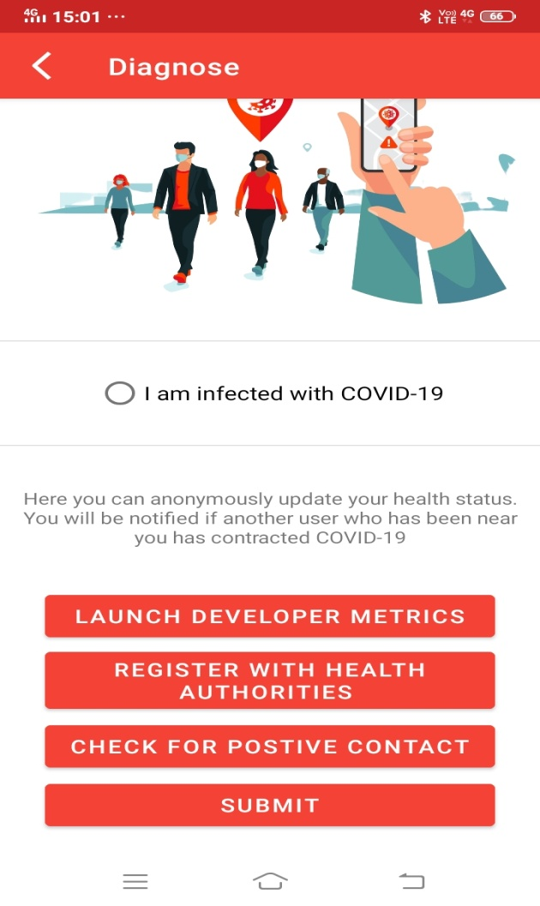

1. Terms and Conditions

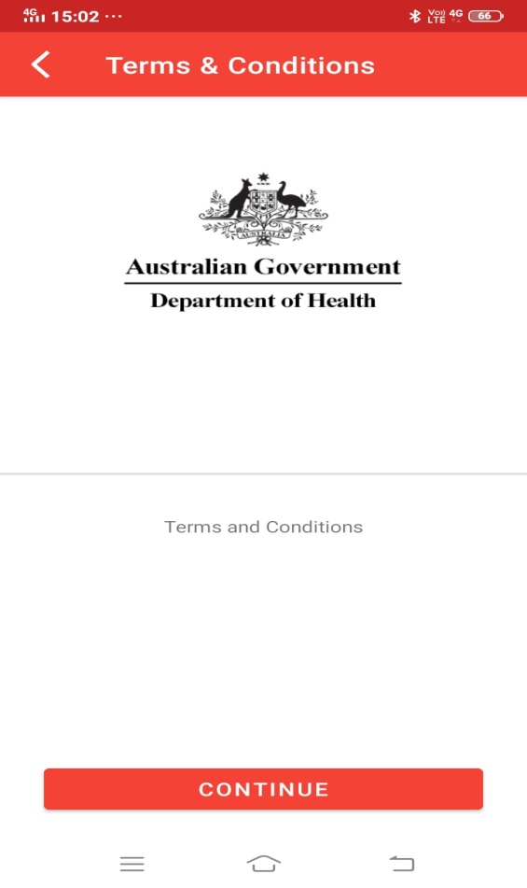

1. Barcode of UUIDs

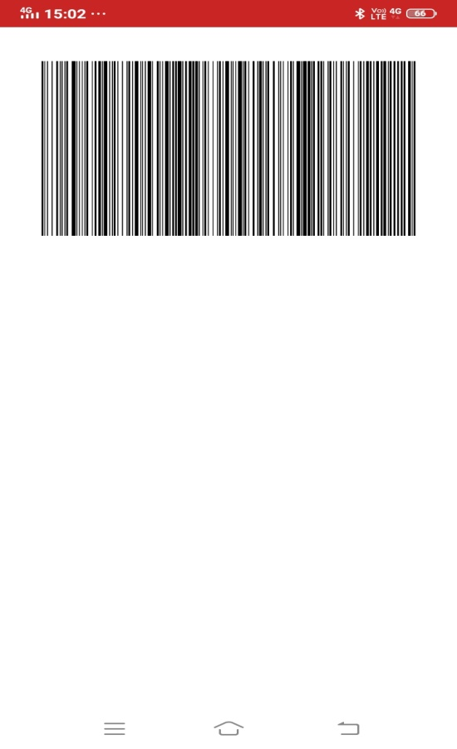

**Future Work-**

1. Work on the consent flow to manage the permissions by the user to approve or disapprove of loading of results.
2. Work on consent flow to validate which users are covid positive or not.